
A Project
Report On
Online Job Portal
By
Komal Ashok Patare
Msc (Computer Science)
Batch: - 2020-5078
Center: -Pune
Under the Guidance of,
Mr.Jayanth V.
Technical Trainer
EduBridge
(School of Coding)

OVERVIEW

The importance of placement system is increasing day by day. Thousands of applicants are depending placement cell. But the applicants are facing so many problems. This project is an attempt to minimize the problems of an applicant to find a correct job. If we can make it an online computerized and a mobile alert process it will be so fast and convenient for the applicants. Far from upsetting matters, however, new technologies have predominantly made life better and considerably easier for most of people, and so it must be concluded that they should be welcomed.
Software does not require a dedicated computer and can be run on almost any PC running Windows OS The package includes the MOB JOBS software and a normal cell phone and data cable. It uses a normal SIM card from a GSM operator with a local mobile number. In functionality it is similar to the four digit short codes but unlike short codes that is billed according to the agreement between the content provider and the service provider and can only be reached from certain networks a long code (Local GSM number) can be accessed from almost anywhere in the world for the price of an Normal SMS depending on location and tariff of the Local GSM operator. Receiving the response is an incoming SMS and is free.

EXISTING SYSTEM

The existing system is a manual system of limitations like accuracy, expense, low speed and efficiency and unformatted outputs. In the existing system, all data processing is done manually. All the files and record books are replaced by the software system. When there are a lot of issues such as retrieval and storage of the information and keeping track of them becomes a tedious task. By implementing a computerized system, the limitation in the present system will be reduced. Manpower can be reduced to a great extent and efficiency and accuracy can be increased to manifold. More over consumption of time can be reduced to far greater extend by the implementation of the proposed system.

PROPOSED SYSTEM
In the proposed system we propose to computerize the above-mentioned activities. In the existing system, all data processing is done manually. When there are a lot of issues such as retrieval and storage of the information and keeping track of them becomes a tedious task. By implementing a computerized system, the limitation in the present system will be reduced. Manpower can be reduced to a great extent and efficiency and accuracy can be increased to manifold. More over consumption of time can be reduced to far greater extend by the implementation of the proposed system.
The proposed computer based information system is aimed at eliminating the limitations of the existing system via increasing speed of information retrieval, by increasing processing speed, data security and hence give accurate reports. The proposed system fully satisfies user needs. All most all the limitations of the existing system are reduced in a great manner. Details are stored in various files from which data can be accessed and manipulated easily.
In the proposed system there are two sections one is administration part in which the following processes are carried out.

MERITS OF PROPOSED SYSTEM
- A lot of manual work which is time consuming and tedious can be reduced.
- Eliminates wrong entries and hence give accurate report.
- Reduce paper work and extra cost.
- Data redundancy can be avoided.
- Data security.
- Information retrieval is faster.
- User friendliness.
- Flexibility.
- The number of registers can be reduced.
- The new system provides data consistency and integrity so that data at any time represent the current status.
- The system should provide better security and control over data.

MODULE DESCRIPTION

1). Applicant registration
2). Company registration
3). Job search
4). Vacancy Registration
5). Message

1) Applicant registration:
The applicant can register into the site by providing his details and he can set his username and password for logging in later.

2) Company registration:
The authority of the company can register into the site by providing its details and they can set its username and password for logging in. They can also specify their requirements for each vacancy.

3) Job search:
Applicants can search for the job vacancies in the fields of their choice and apply as interested.

4) Vacancy registration:
Authority of the company can provide all the necessary information about the vacancies in each post along with eligibility criteria.

5) Message:
Software selects the apt ones from the registered applicants for each post and informs them by a mobile alert. The message includes interview details.

SYSTEM SPECIFICATION
HARDWARE REQUIREMENTS:
- Minimum Requirements
Processors : Intel Pentium Pro or Processor running at 133 MHz
Hard Disk : 1.2 GB Hard Disk
RAM : Client Level – Minimum 128MB
- Recommended Requirements for peek performance
Processors : Intel Pentium III running at 450 MHz
RAM : Client Level – Minimum 512MB
Display Type: SVGA Color Monitor
Keyboard : Enhanced 104 Standard
Mouse : PS/2 2 Button

SOFTWARE REQUIREMENTS:
Operating System : WINDOWS 2000/2003/
XP/WINDOWS 7/WINDOWS VISTA
TOOLS USED:
Front end: ECLIPSE
Back end: MYSQL, TOMCAT SERVER

TABLE STRUCTURES:
The structure of all tables included in the project is as under:-
1.INTERVIEW
+-----------+-------------+------+-----+---------+-------+
| Field | Type | Null | Key | Default | Extra |
+-----------+-------------+------+-----+---------+-------+
| can_uname | varchar(50) | YES | MUL | NULL | |
| com_name | varchar(50) | YES | MUL | NULL | |
| iv_date | date | YES | | NULL | |
| iv_time | varchar(20) | YES | | NULL | |
| iv_place | varchar(50) | YES | | NULL | |
+-----------+-------------+------+-----+---------+-------+
2.EMPLOYER
+----------+-------------+------+-----+---------+-------+
| Field | Type | Null | Key | Default | Extra |
+----------+-------------+------+-----+---------+-------+
| emp_name | varchar(50) | NO | PRI | | |
| emp_pass | varchar(50) | YES | | NULL | |
| emp_web | varchar(50) | YES | | NULL | |
+----------+-------------+------+-----+---------+-------+

3.APPLICANT
+----------+-------------+------+-----+---------+-------+
| Field | Type | Null | Key | Default | Extra |
+----------+-------------+------+-----+---------+-------+
| fname | varchar(50) | NO | | NULL | |
| lname | varchar(50) | NO | | NULL | |
| gender | varchar(10) | NO | | NULL | |
| username | varchar(50) | NO | PRI | NULL | |
| password | varchar(50) | NO | | NULL | |
| email | varchar(50) | NO | | NULL | |
+----------+-------------+------+-----+---------+-------+
4.JOB
mysql> desc job;
+----------+-------------+------+-----+---------+-------+
| Field | Type | Null | Key | Default | Extra |
+----------+-------------+------+-----+---------+-------+
| c_name | varchar(50) | NO | PRI | | |
| c_web | varchar(50) | YES | | NULL | |
| vacancy | int(50) | YES | | NULL | |
| salary | int(50) | YES | | NULL | |
| job_desc | varchar(50) | YES | | NULL | |
| location | varchar(50) | YES | | NULL | |
| sel_post | varchar(50) | YES | | NULL | |
| iv_date | date | YES | | NULL | |
| iv_time | varchar(20) | YES | | NULL | |
| iv_place | varchar(50) | YES | | NULL | |
+----------+-------------+------+-----+---------+-------+
SNAP SHOT

- HOME PAGE:
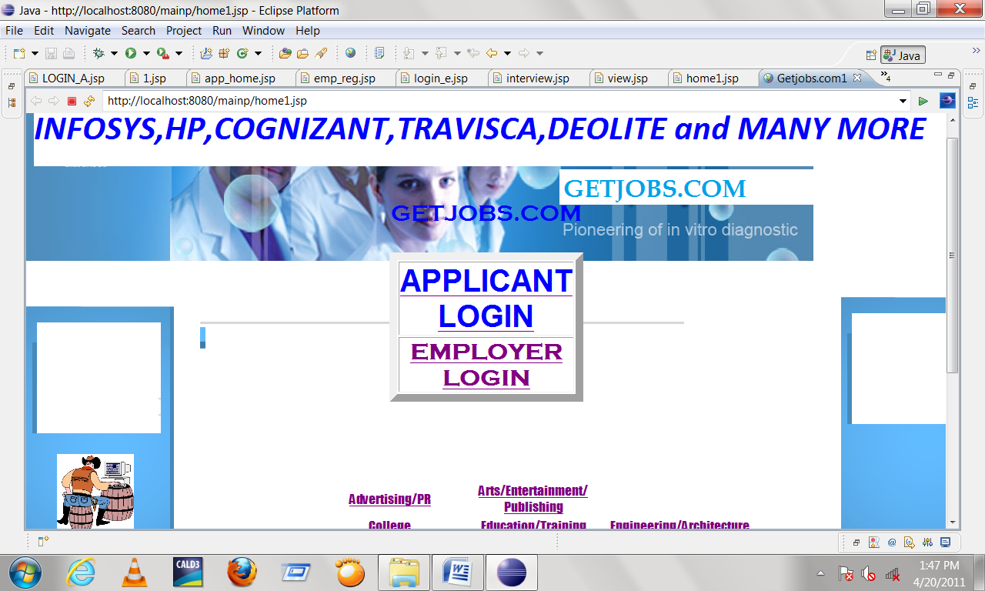

- LOGIN PAGE:
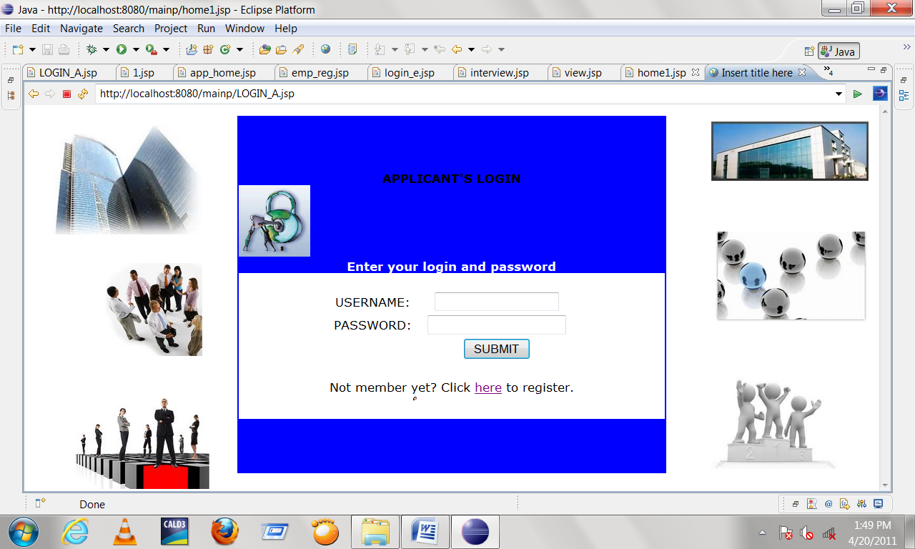
- CANDIDATE’S HOME PAGE:
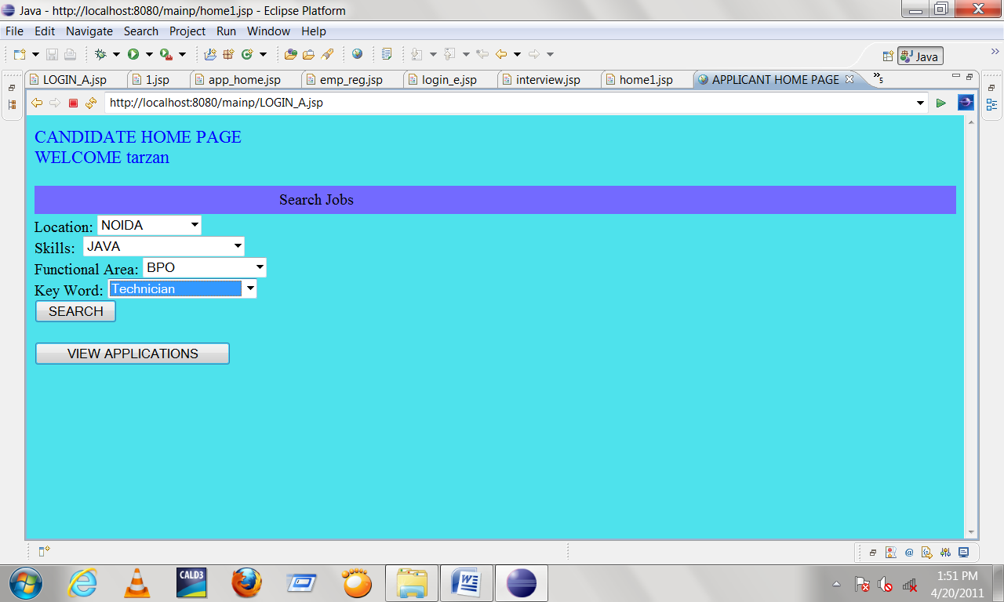
- INTERVIEW PAGE:
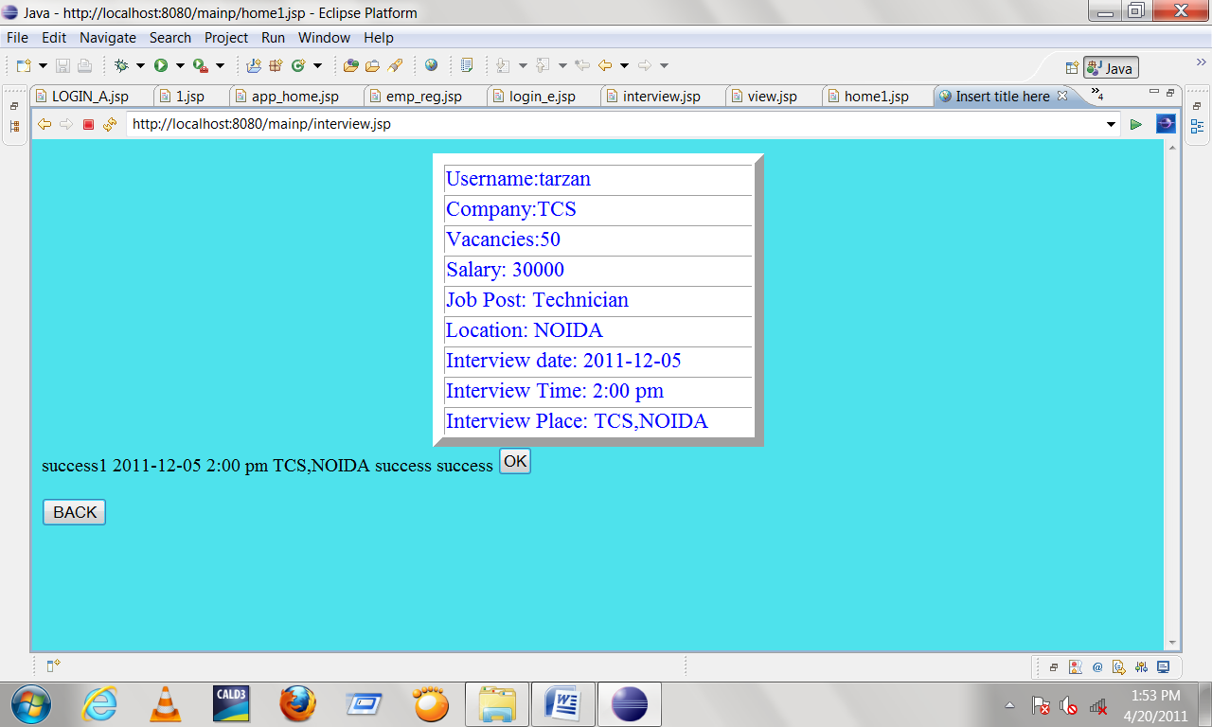

- CANDIDATE’S REGISTRATION PAGE:
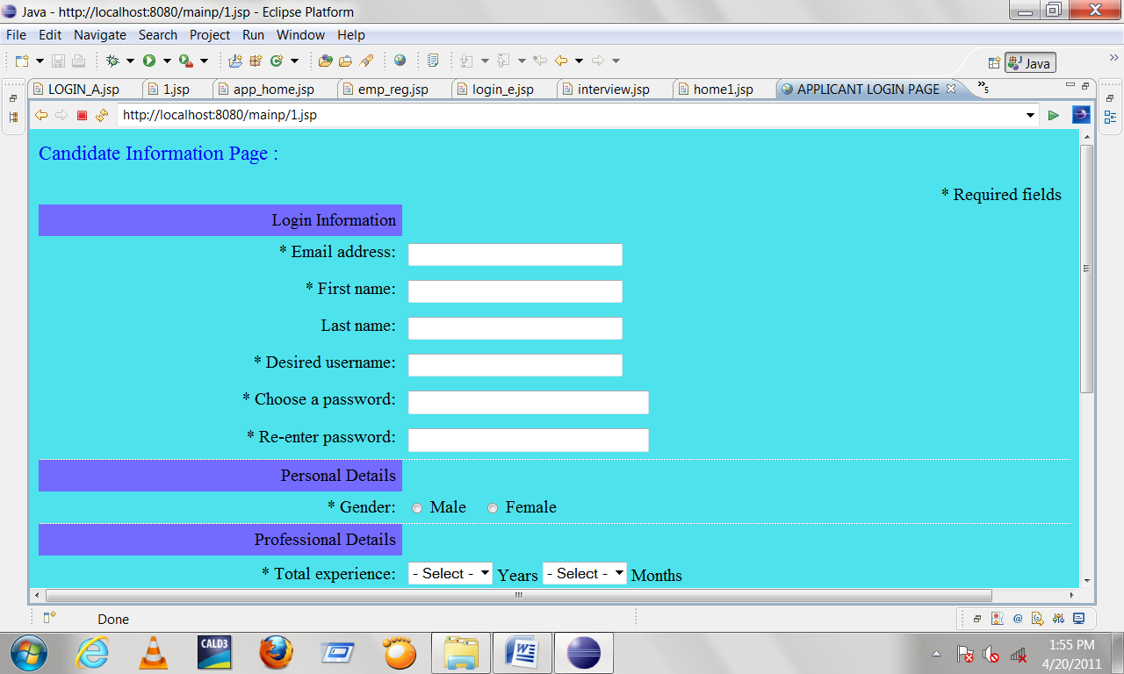

FUTURE SCOPE

There have been numerous cases of computer glitches, errors in content, and security lapses reported in online job searching .So in the near future the so –called software could be made more secure and reliable. While electronic glitches are rare, they have been known to occur, for instance when computer crashes voided the efforts of thousands of student. There are also cases in which the correction software has corrupted database. So the software can be programmed well so as to avoid corrupted information

CONCLUSION

The Online job portal System is developed using java and sql fully meets the objectives of the system for which it has been developed. The system is operated at a high level of efficiency and all the job seekers and user associated with the system understands its advantage. The system solves the problem. It was intended to solve as requirement specification.

